Mini Project
Ǫuetion1: Create a MySǪL table called playlists to store Spotify-style music playlists, with columns: playlist_id (primary key), user_id (foreign key), name (varchar), and created_at (datetime). Write the CREATE TABLE statement.
Ans:
USE mydb;
CREATE TABLE Users (
user_id INT PRIMARY KEY
);
CREATE TABLE playlists ( playlist_id INT PRIMARY KEY, user_id INT,
name VARCHAR(100),
created_at DATETIME,
FOREIGN KEY (user_id) REFERENCES Users(user_id)
);

Ǫuetion2: Insert three sample records into the playlists table: one for a user with a 'Workout Mix', one with a 'Chill Vibes', and one with a 'Top Hits' playlist. Use realistic data for each field.
Ans:
INSERT INTO Users (user_id) VALUES
(1),(2),(3);

INSERT INTO playlists (playlist_id, user_id, name, created_at) VALUES
(1, 1, 'Morning Beats', '2026-10-08 07:30:00'),
(2, 2, 'Relaxing Tunes', '2026-10-07 18:45:00'),
(3, 3, 'Party Playlist', '2026-10-06 20:15:00');

SELECT * FROM playlists;

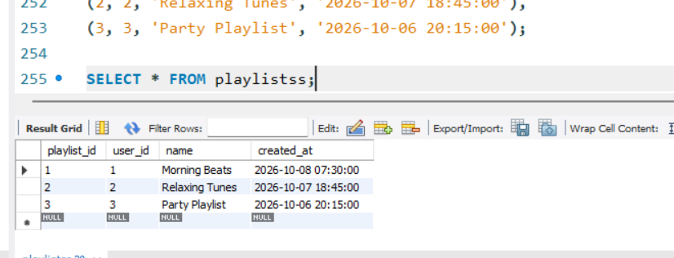

Ǫuestion3: Write an SǪL UPDATE statement to rename the 'Chill Vibes' playlist to 'Evening Chill' for a specific user_id.
Ans:
UPDATE playlists
SET name = 'Evening Chill' WHERE name = 'Chill Vibes' AND user_id = 2;
SELECT * FROM playlists WHERE user_id = 2;
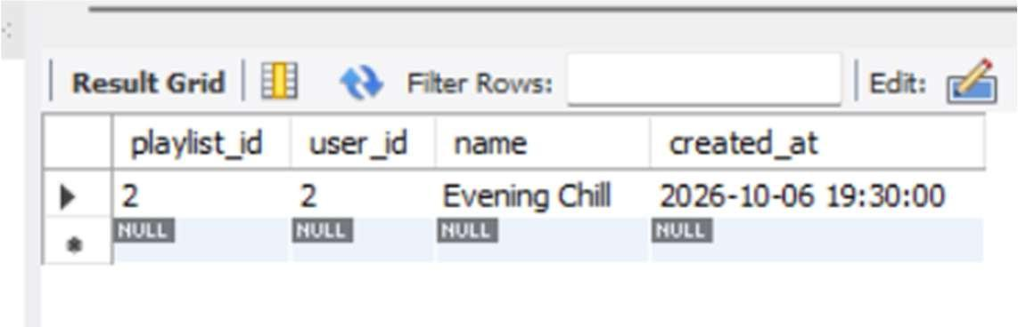
Ǫuestion4: Write a DELETE statement to remove a playlist named 'Workout Mix' for a given user_id from the playlists table.<br><br><em><strong>Hint:</strong> Make sure your WHERE clause targets only the intended row.</em>
Ans:
DELETE FROM playlists
WHERE name = 'Workout Mix' AND user_id = 1;
SELECT * FROM playlists;
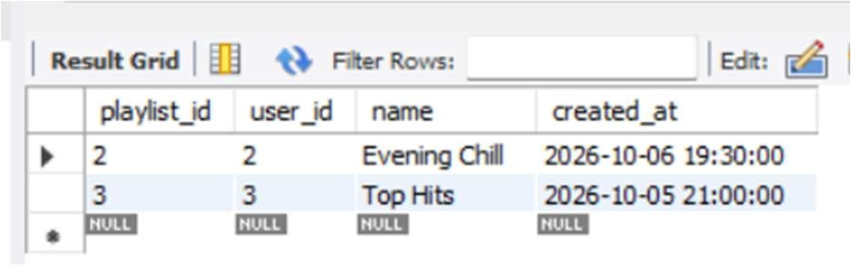
Ǫuestion5: Create a stored procedure named GetMonthlyPlaylistCount that takes a user_id and a month (as an integer) as input, and returns the total number of playlists the user created in that month.<br><br><em><strong>Hint:</strong> Use the MONTH() function in your WHERE clause.</em>
Ans:
DELIMITER //

CREATE PROCEDURE GetMonthlyPlaylistCount( IN p_user_id INT,
IN p_month INT
) BEGIN
SELECT COUNT(*) AS total_playlists FROM playlists
WHERE user_id = p_user_id
AND MONTH(created_at) = p_month; END //

DELIMITER ;
CALL GetMonthlyPlaylistCount(2, 10);
